W1D3 Lab

Group members:

*\* 15. Nguyen, Ha Vu Duy  
* 20. Pham, Van ty*

**Question 1:**

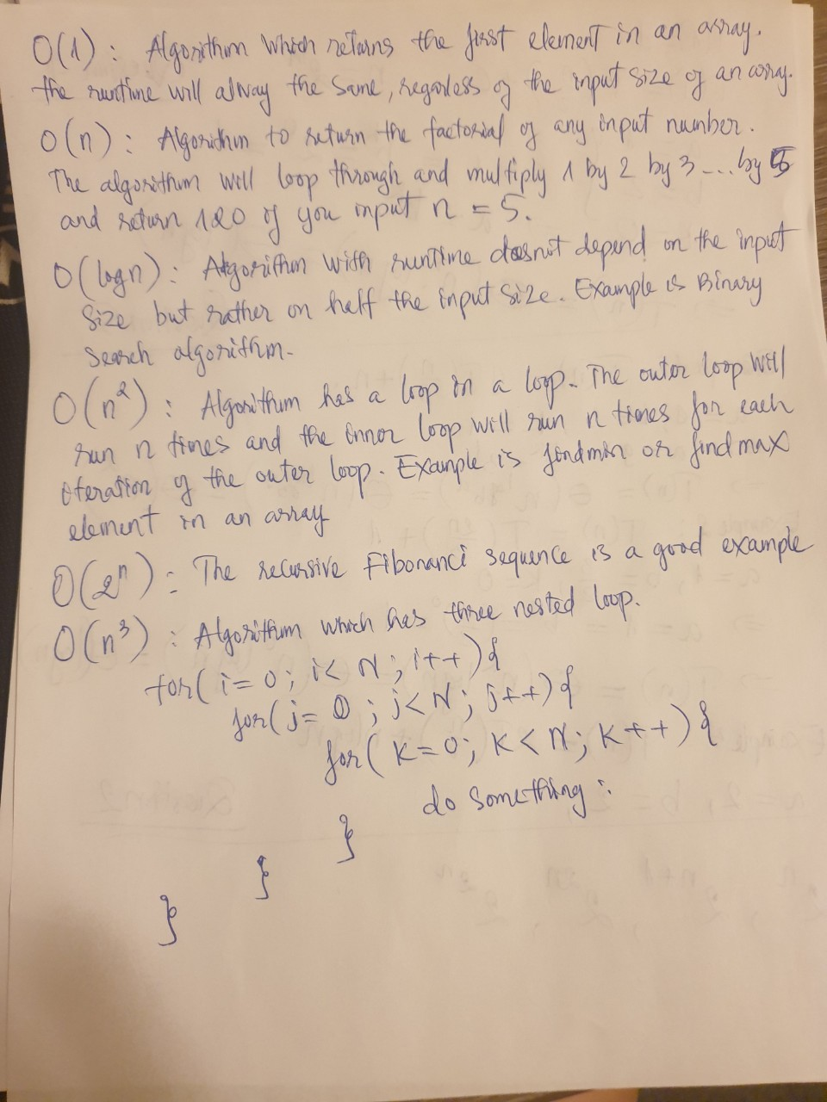

**Question 2, Question 4, and Question 5:**

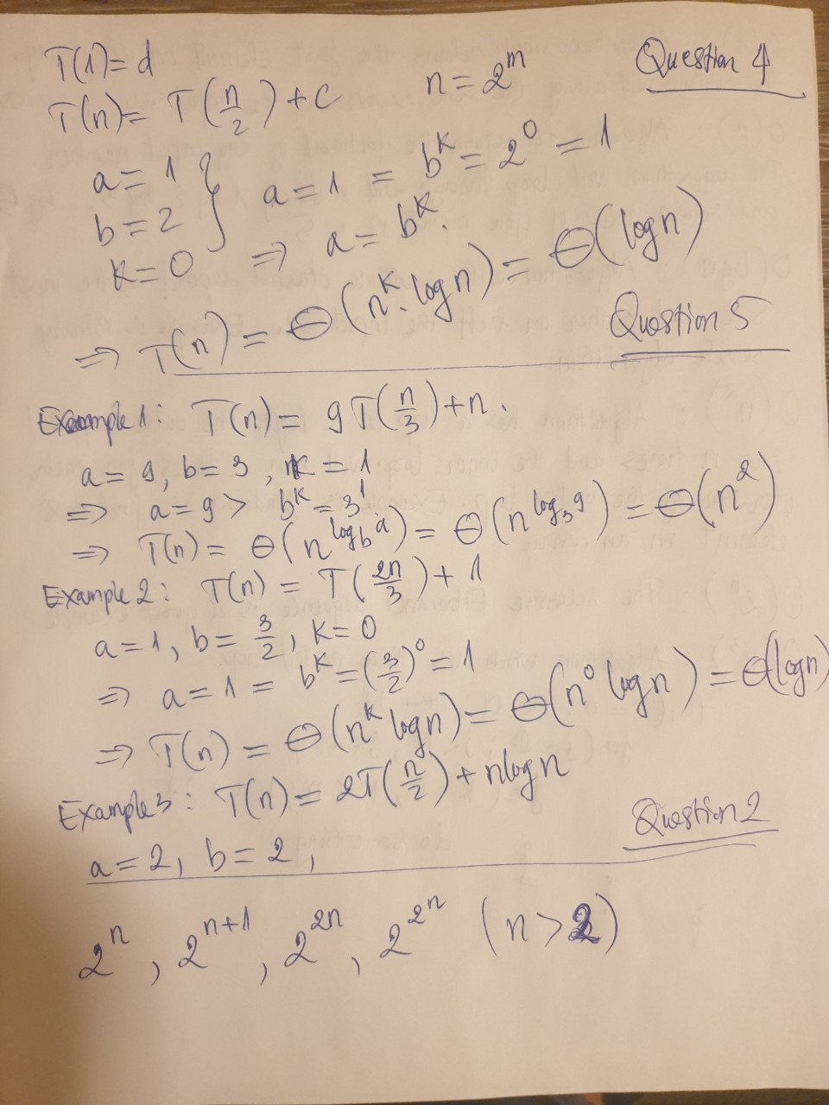

**Question 3:**

